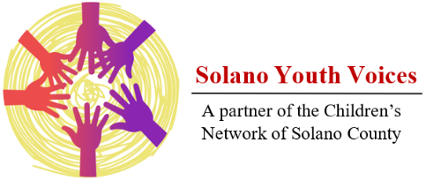
Kimberly Franco
Council Member

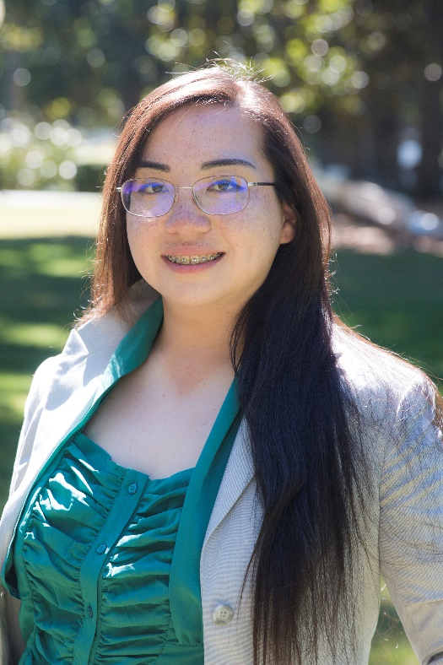
Kimberly Franco’s experience with Solano Youth Voices was multi-layered and demonstrates the individual impact this a program can have on youth whose voices have been muted for too long. She joined the group already having had some experience in behind-the-scenes advocacy work and data analysis. She also came, however, with debilitating personal trauma and mental health challenges that prevented her from using her skills in a leadership role, and from publicly representing her peers. Solano Youth Voices was structured to create a safe place where “at-risk” youth like Kimberly could blossom into role models for their peers in the community and develop impactful policy recommendations.

Throughout the program, Kimberly developed multiple skillsets simultaneously, all while building the relationships that would support her growth as a leader. With her peers, she identified youth priorities and created a policy platform representing youth in Solano County. As she honed her survey writing and data analysis skills, Kimberly co-authored a youth survey as well as helped to collect, enter, and analyze data from the surveys. It was this work that helped the team complete a critical step in the process of building policy recommendations: identify Education, Mental Health, Bullying, and Homelessness as priorities.

At the same time, Kimberly was also developing her public speaking and interpersonal skills. Through encouragement and practice with her peers, she began leading focus groups and speaking with student groups. Eventually, she graduated to giving presentations and holding research meetings with youth and adult issue experts across Solano County. Again, she was a key player in another critical step: learning about potential policy recommendations and researching their feasibility and potential for impact. In other words, Kimberly and her youth colleagues grew alongside the policy platform.

Kimberly’s story is really a story of the potential and value even our most vulnerable youth bring to the table. Importantly, she is a role model for other young people who struggle with their mental health, immigration difficulties, and being bullied, among other life experiences. Especially while leading a focus group of youth impacted by immigration, Kimberly demonstrated to her peers that her voice matters, and their voices matter, too.

The policy platform Kimberly helped craft is a direct reflection of those voices alongside hundreds of others. Without the healing relationships and support structure Solano Youth Voices offered, Kimberly would not be the burgeoning young leader she is today. In her own words, “The first step to heal from trauma is to open up to people you can trust… Thanks to you guys, I am building my self-worth and confidence again.” Kimberly is using her newfound confidence to empower other youth to ensure that their voices are included in meaningful policy change and implementation going forward.

